1. You need to know 3 important terminologies when working with **Cucumber Automation**.
   1. **Feature File**: BDD Test Cases what we want to automate.
   2. **Step Definition File**: Code about how to automate.
   3. **Test Runner**.
2. **Feature File**:
   1. We already talked about feature file, how to write scenarios inside it with **Gherkin Style** (BDD) with “Given, When, Then”.
   2. We will automate the test cases inside this feature file.
3. **Step Definition File**:
   1. Every step in the scenario (like given, when then, and, but etc) must be mapped with **related automation code**.
   2. Such code will be placed in Step Definition File.
4. **Test Runner**:
   1. It triggers all the test cases.
   2. Test Runner needs the followings:
      1. The location of feature files as a feature file contains test cases.
      2. The location for automation code (basically location to Step Definition Files).
5. Let’s begin with creating **Feature File** in eclipse.
6. Graphical user interface, application

   Description automatically generated
7. 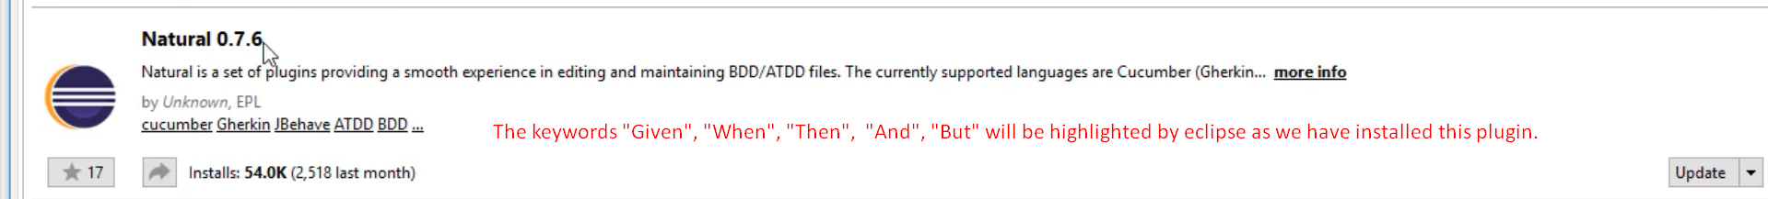
8. 